

**1.1 Introduction**

**Prima bus** is an application that lets you search, book bus ticket, view your booked tickets and cancel booked tickets. Those who are interested in inquiring about the Bus Type, its Tickets Price, available seats, facility of the bus etc. has to walk to the Booking office. This application makes this easy, now you can enquire about the bus, book bus ticket and cancel your ticket sitting at your home.

A new system is helpful to both employees as well as the customers. New system provides help to the customer as they can inquire about the Bus model, its Ticket price, available Seats, facility of the bus etc. and they don’t need to walk to the office. There is login and password service for employee and Regular customers can use this system .The implementation uses Java which is a set of [computer software](https://en.wikipedia.org/wiki/Computer_software) and specifications developed by [Sun Microsystems](https://en.wikipedia.org/wiki/Sun_Microsystems), which was later acquired by the [Oracle Corporation](https://en.wikipedia.org/wiki/Oracle_Corporation), that provides a system for developing [application software](https://en.wikipedia.org/wiki/Application_software) and deploying it in a [cross-platform](https://en.wikipedia.org/wiki/Cross-platform) computing environment. Java is used in a wide variety of [computing platforms](https://en.wikipedia.org/wiki/Computing_platform) from [embedded devices](https://en.wikipedia.org/wiki/Embedded_device) and [mobile phones](https://en.wikipedia.org/wiki/Mobile_phone) to [enterprise servers](https://en.wikipedia.org/wiki/Enterprise_server) and [supercomputers](https://en.wikipedia.org/wiki/Supercomputer). While they are less common than standalone Java applications, [Java applets](https://en.wikipedia.org/wiki/Java_applet) run in secure, [sandboxed](https://en.wikipedia.org/wiki/Sandbox_(computer_security)) environments to provide many features of native applications and can be embedded in [HTML](https://en.wikipedia.org/wiki/HTML) pages.

**Following are terms used throughout this documentation:**

* **Sign Up: -**

Sign Up is used to create an account for a new customer so that he/she can use the features available in the application such as searching buses from one place to another , to check if seats are available in the bus he/she wants to travel , to book as many tickets he/she wants, to view his/her bookings and to cancel a booked ticket and this can be done by simply clicking on the Sign Up button and providing his/her information to store in the database.

* **Login: -**

Login is the procedure used to get access to an application so that he/she can use the features available in the application such as searching buses from one place to another , to check if seats are available in the bus he/she wants to travel , to book as many tickets he/she wants , to view his/her bookings and to cancel a booked ticket and this can be done by simply clicking on the Login button provided he has a registered User Id and password.

* **Search Bus:-**

Search Bus button is used to search buses for a journey from one place to another. The customer can see all the buses available and chose the bus which he finds most suitable according to the bus departure time , its fare or bus type i.e. AC or non-AC. This can be simply done by entering the information of your journey and clicking the Book Ticket button.

* **View Bookings: -**

View Bookings is used to view all the booking details of the customer required that the customer has logged in a has booked at least one ticket in any bus. This can be simply done by clicking on the View Bookings button once you are logged in.

* 1. **System Requirements: -**

**2.2.1 Hardware Requirements Specification:-**

**2.2.1.1 Minimum User Requirement:**

* + - * Processor 2 GHZ
      * RAM 1 GB
      * Disk Space 15 GB Of Free Space
    1. **Software Requirements Specification:-**

**2.2.2.1 Minimum User Requirement:**

* Net Beans IDE 8.1 or more
* MySQL

**2.3 DATA FLOW DIAGRAM: -**

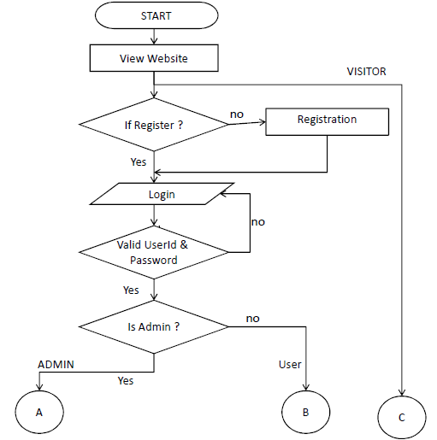

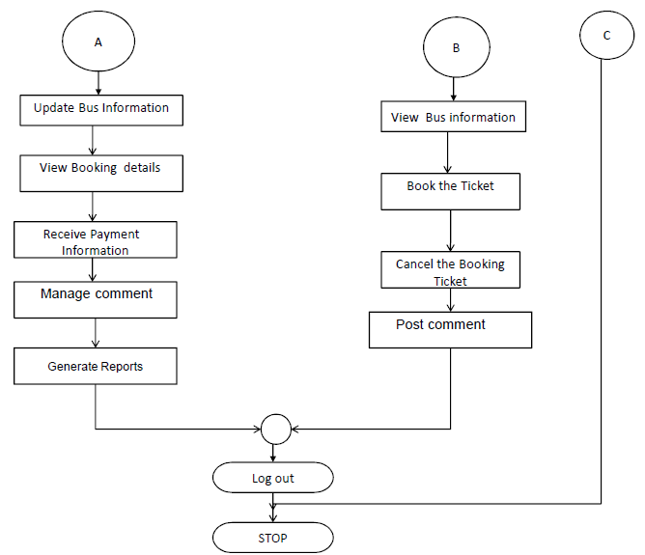

**2.4 ER DIAGRAM: -**

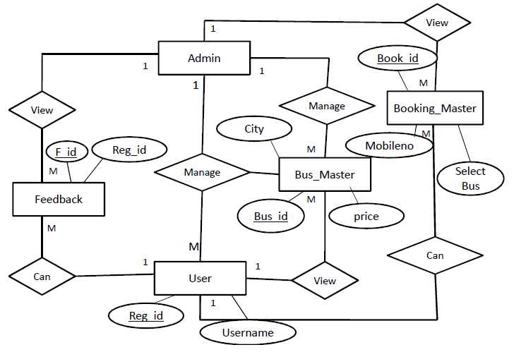

**2.5 Data Dictionary: -**

**Table Name: user**

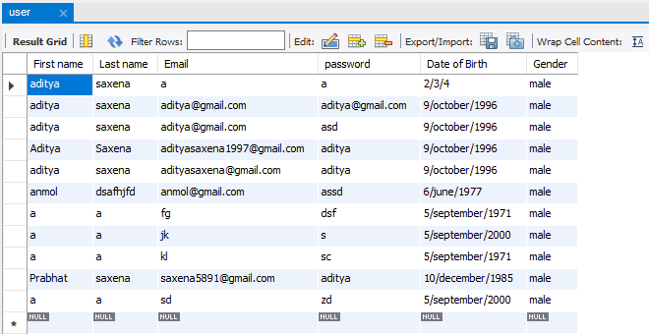

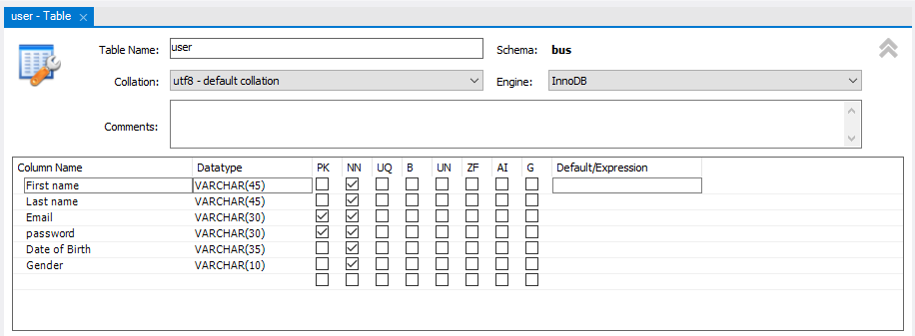

**Table Name: available bus**

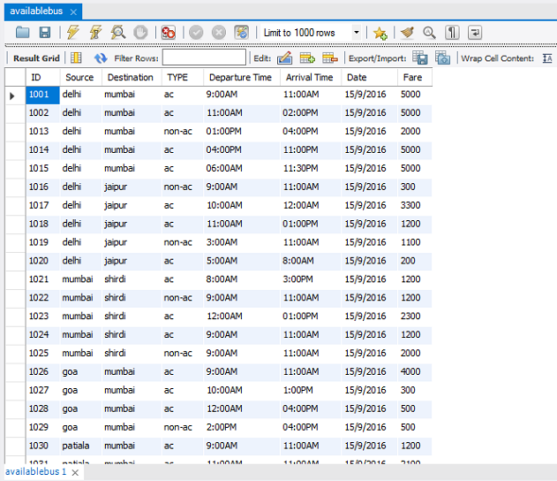

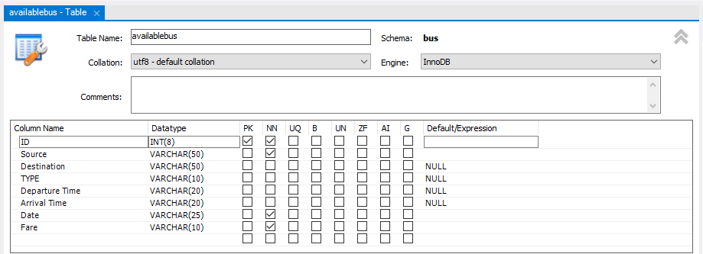

**Table Name: reserve**

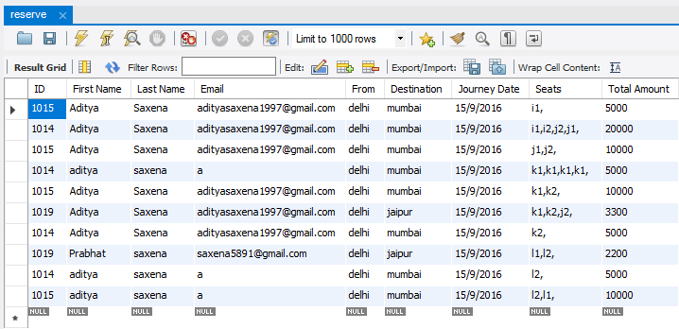



**2.6 Output Screenshots: -**

**2.6.1 Sign Up: -**

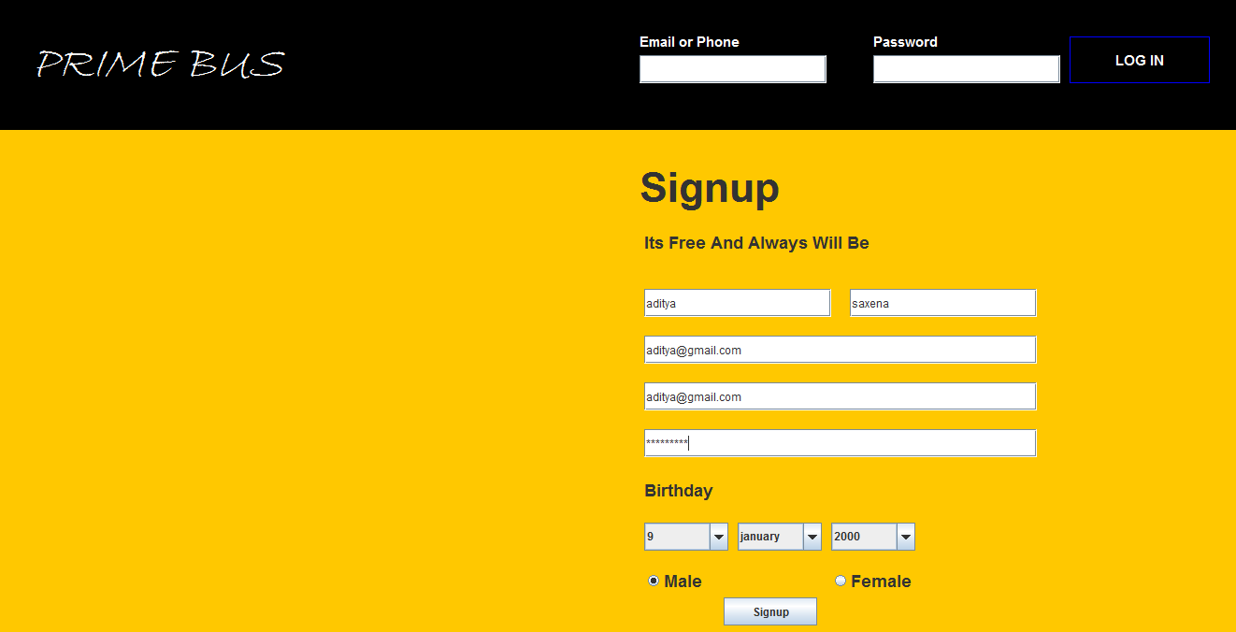

**2.6.2 Log in: -**



**2.6.3 Search Bus: -**

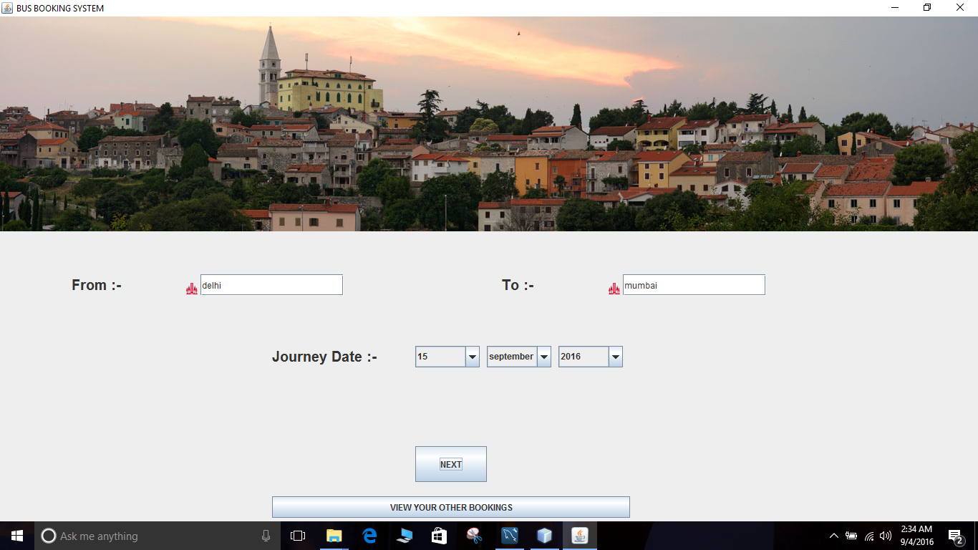

**2.6.4 Buses Available: -**

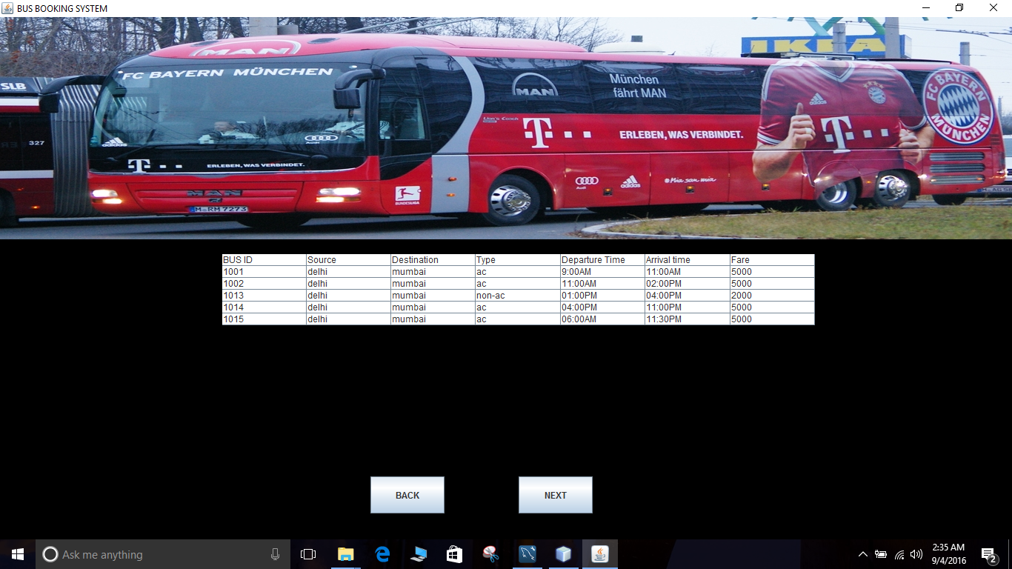

**2.6.5 Selecting Seats: -**

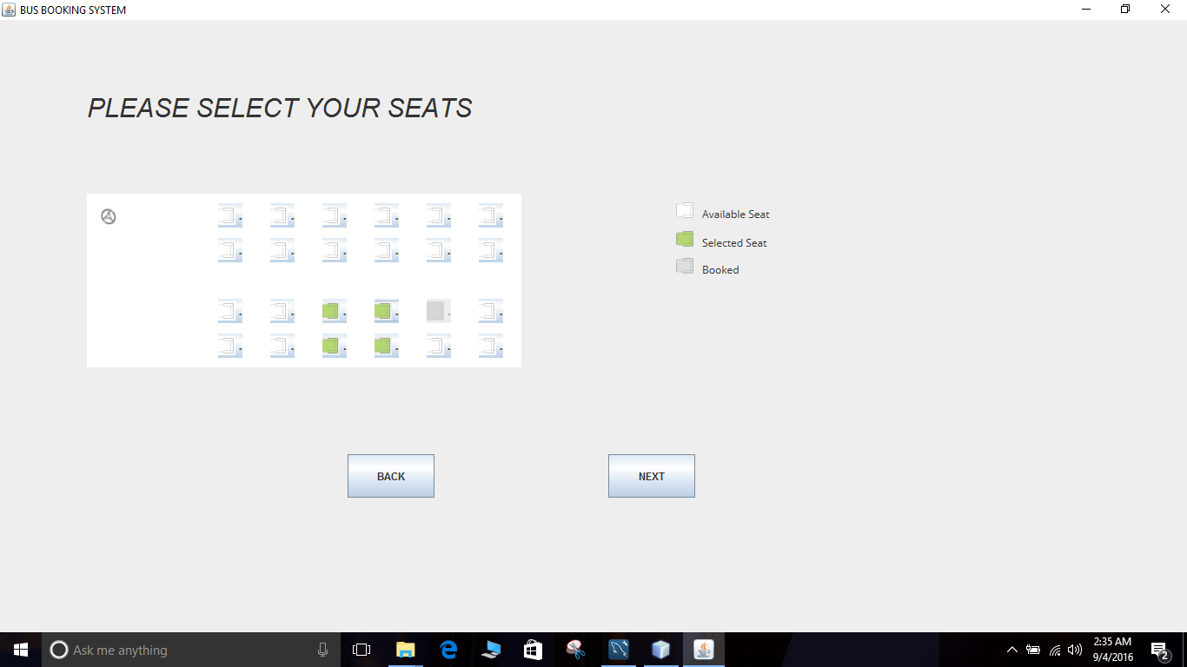

**2.6.6 Booking Confirmation: -**

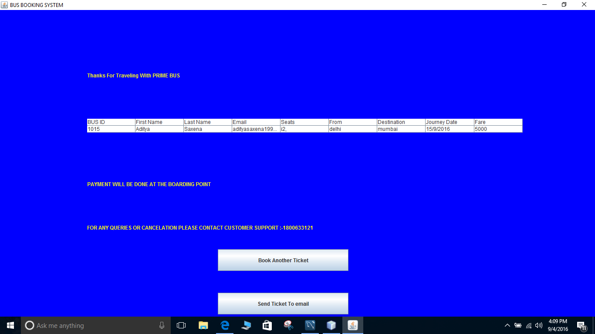

**2.6.7 View Booking Details: -**

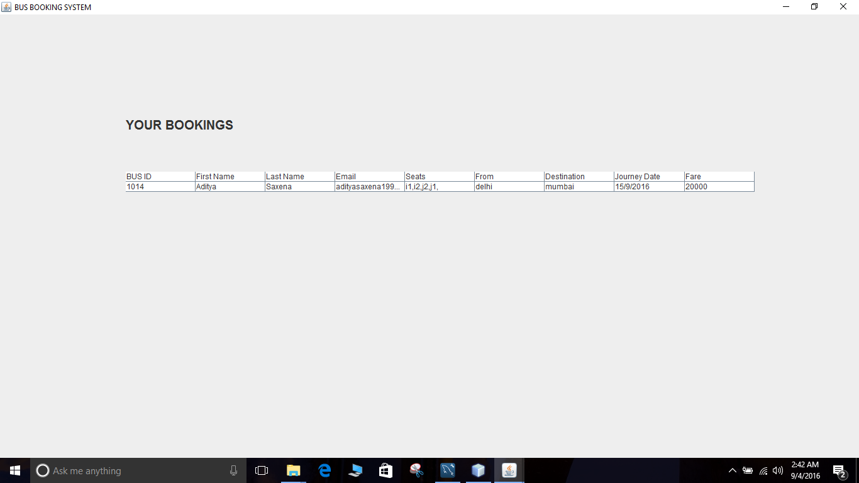

**2.6.8 Send Ticket to Email Id: -**



**2.6.9 Email Confirmation from Prime Bus: -**

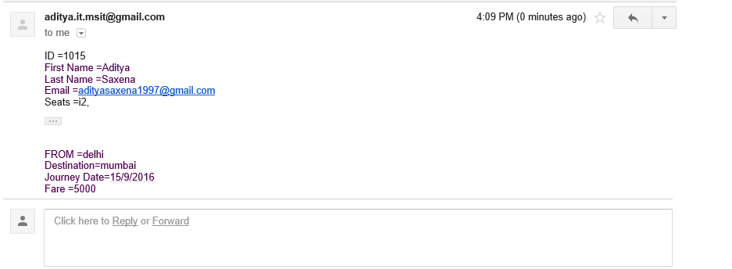

**2.6.10 View Booking Details: -**

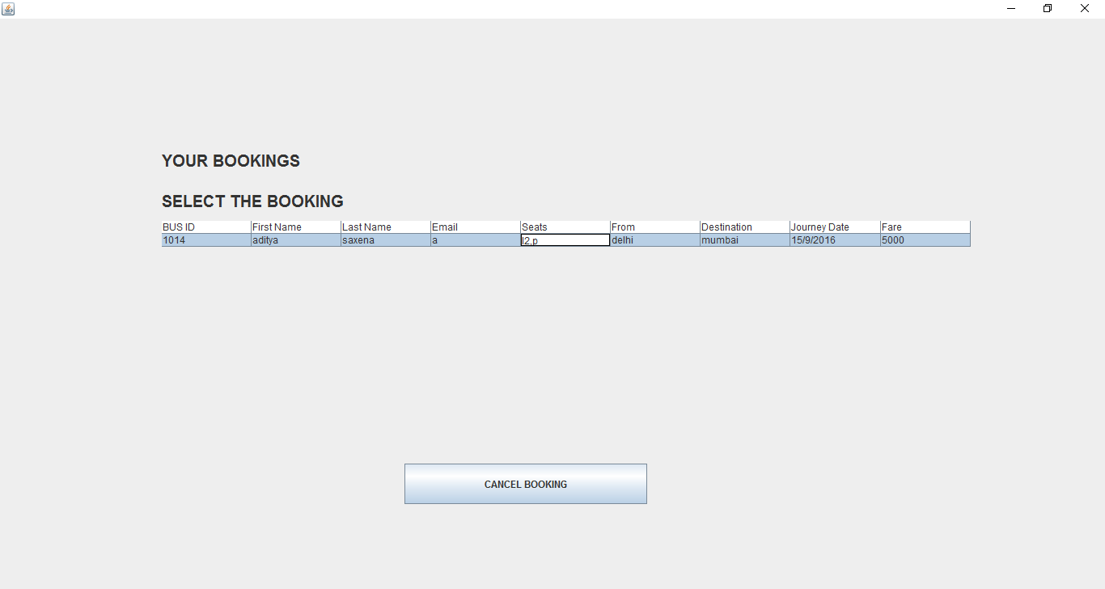

**2.7 Testing: -**

**2.7.1 Unit Testing:-**

This is the testing process which we can do manually because in this testing program

is a tested individually using dummy record to see whether that program produce

satisfied output as the company and validation also.

**2.7.2** **Validation Testing:-**

In this requirements established as part of software requirements analysis are validated

against the software that has been constructed. Validation testing provides

final Assurance that software meets all functional, behavioral and performance

requirements. Validation can be define in many ways but a simple definition is that

validation succeeds when software Function in a manner that can be reasonably by

the customer.

## Validation test criteria

## Configuration review

## Alpha and Beta testing (conducted by end user)

**2.7.3 System Testing: -**

System testing is actually a series different test whose primary purpose is to full exercise the computer base system .Where the software and other system elements are tested as

whole. To test computer software, we spiral out along streamlines that broadens the scope of testing with each turn.

The last higher-order testing step falls outside the boundary of software Engineering and

in to the broader context of computer system engineering.Software,once validated,must

be combining with order system

Elements(e.g.hardware,people,databases).

System testing verifies that all the elements Mesh properly and that overall system function/performance is achieved.

# Recovery Testing

# Security Testing

# Stress Testing

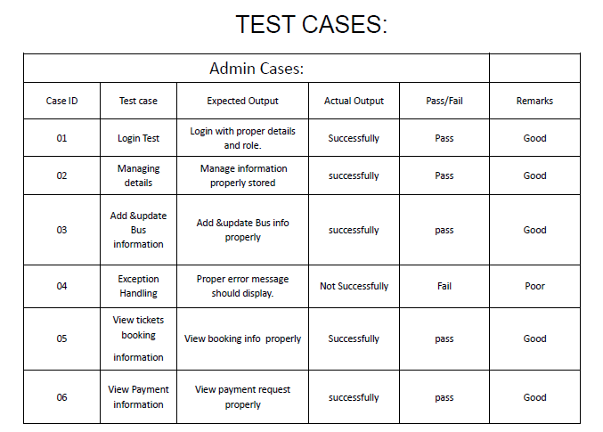

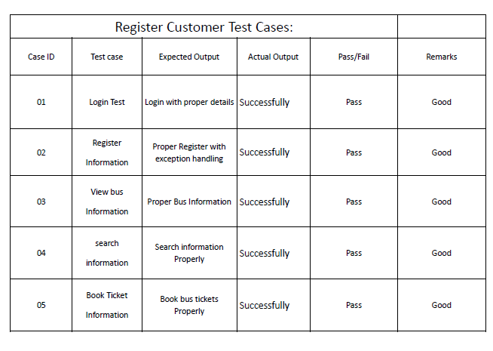

**2.8 Post Implementation Review**

After the system is implemented and conversion is completed a review of

system is usually conducted by user and analyst. This is called post implementation

review.

The most fundamental concern post implementation review to determining

whether the system has met its objective; that is analysts want to know

if the performance the performance level of improved and if the system is

producing the result intended. If neither is happening, one may question whether

the system can be considered successful.

The new system needs less manpower, provide facility for Book Tickets and Latest News for bus information.

**2.9 FUTURE ENHANCEMENT: -**

We think that not a single project is ever considered as complete forever.

Because our mind is always thinking something new and our necessities

also are growing day by day we always want something more than what we have our

application also

If you see at the first glance then you find it to be complete but we want to

make it still mature and fully automatically.

The future perspective of our project can linking our booking system with other centralized bus services so that user has an ease of booking and travelling.

Other then this for long route journeys food facility and its variety can be added.

With the use of GPS every traveler can get advance map of route to be followed during journey. Making a mobile app for the user is also a first step development.

**2.10 BIBLIOGRAPHY: -**

During the development of my system, I have taken the reference from Books and journals, which I would like to mention in this section.

These books acted as my tutors during the system development.

### JavaBeans: Developing Component Software in Java by John Osborn

### Java Network Programming by  ‘O'Reilly & Associates

### The Java Developer's Resource by Elliott Hardy

Besides these I was referring the online manuals from the sites.

www.google.com

www.GSRTC.com

www.neeta.com

www.gujrat.com

www.paswanath.com